Holiday Game
- Show pictures and descriptions of 3 holidays.
- Ask students what other U.S. holidays they know about. They should answer some of the following questions:
When is it?
What do we celebrate?
What food do we eat?
What do people do?
- Use Google Images to show pictures of holidays that students mention, and ask them to describe what they see.
Flag Day is on June 14. It is also called National Flag Day. It is a holiday to celebrate the adoption of the American Flag by the Second Continental Congress in 1777. It is not an official federal holiday. Schools, banks, and post offices are open on Flag Day. (3 pages)
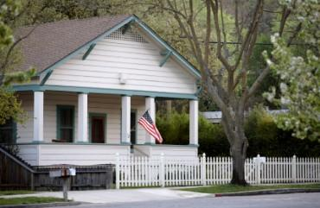 | When is Flag Day?  - It is on June 14.  - People display the flag on this day.

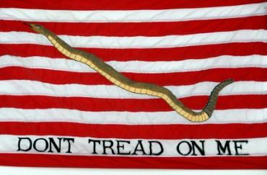 | What flag is this?  - This is an old flag that was used by the United States Navy during the American War of Independence in 1775.  - It has a snake on it. It says, DON'T TREAD ON ME.

Father's Day is a special day to honor fathers and grandfathers. It is on the third Sunday of June. Fathers receive cards and gifts on Father's Day. It is important to thank your father and grandfather for all the things they do. (3 pages)
 | When is Father's Day?  - It is on the third Sunday of June. In 2014, it is on June 15.  - We celebrate it by giving cards and gifts to our fathers and grandfathers.  - We say "Happy Father's Day!"

 |  | Why are fathers special?  - Fathers are special because they take care of their families.
 | What do fathers like to do on Father's Day?  - They like to spend the day with their families.  - They like to relax.

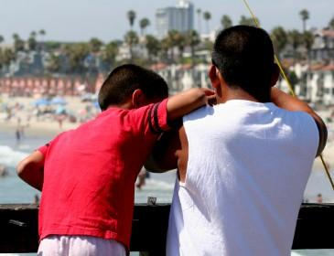 | What else do fathers like to do?  - They like to go fishing.  - This father is fishing with his son.

 | How many children does this father have?  - He has two children.

The Fourth of July is also called Independence Day. It is a federal holiday. Schools, banks, post offices, and government offices are closed on the Fourth of July. The Fourth of July is our most important national holiday because it celebrates the Declaration of Independence. The Declaration of Independence announced America's independence from Britain. It was adopted by the Continental Congress on July 4, 1776, in Philadelphia, Pennsylvania. Thomas Jefferson was the main writer of the Declaration of Independence. (3 pages)
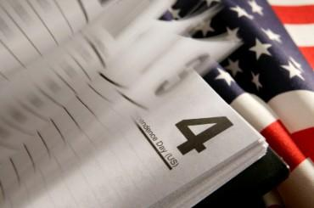 | When is Independence Day?  - It is on July 4th.  - It is also called the Fourth of July.

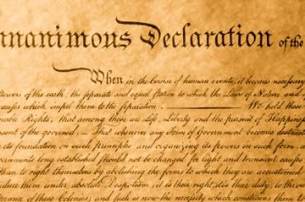 |  | Why is it an important day?  - It is an important day because it is the day the American colonies declared their independence from Britain.
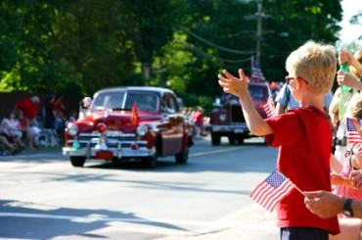 | Are there parades on the Fourth of July?  - Yes, there are.  - Many cities have parades.

 | What foods are popular on the Fourth of July?  - Hot dogs and hamburgers are popular foods.  - Many people barbecue hot dogs and hamburgers in their backyards.

