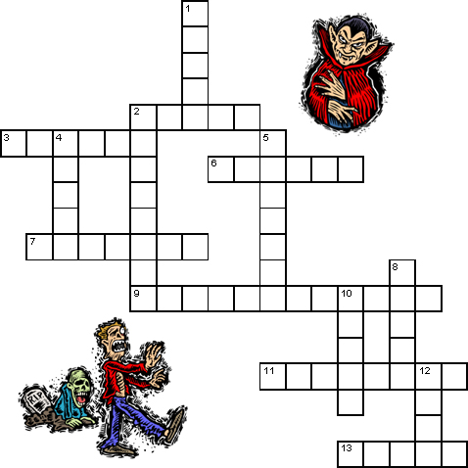 |  | 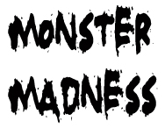  Across  2. She rides a broom.  3. This monster is a dead person’s body.  6. This monster breathes fire and looks like a large snake or lizard.  7. A one-eyed giant.  9. This monster was made in a laboratory by a scientist.  11. This monster is made of bones.  13. A monster from outer space.
Down  1. This monster is the spirit of a dead person  2. A monster that comes out when the moon is full.  4. A monster from the pyramids of Egypt.  5. A monster that drinks blood.  8. A huge person.  10. This monster hides under bridges and waits to eat people.  12. This monster looks like a large ugly person and usually lives in a cave. | 