Find the Thanksgiving words below in the grid:

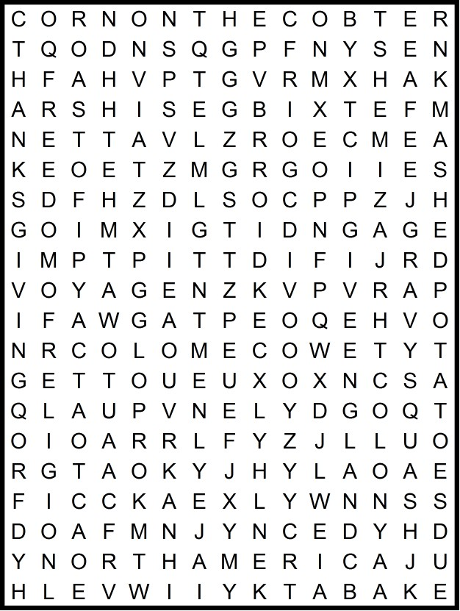 |  |  | 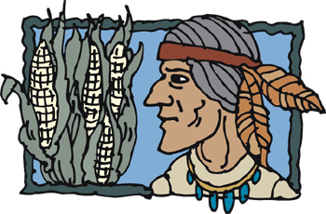  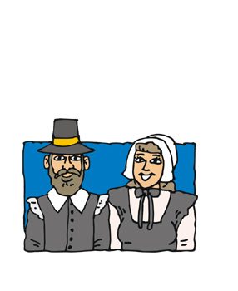
Atlantic Ocean  bake  carve  colony  corn on the cob  cornucopia  England | feast  freedom of religion  get together  gravy  mashed potatoes  Mayflower  North America | pilgrim  pumpkin pie  roast  squash  Thanksgiving  turkey  voyage

Find the Thanksgiving words below in the grid:

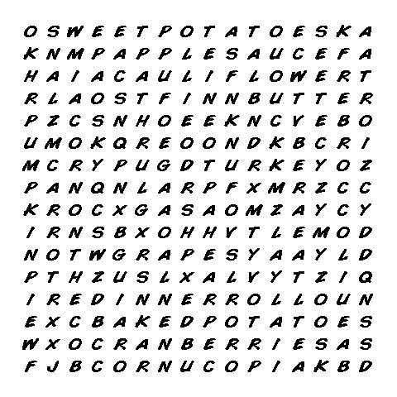 |  |  |  | 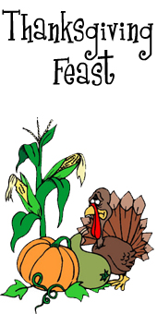
 | 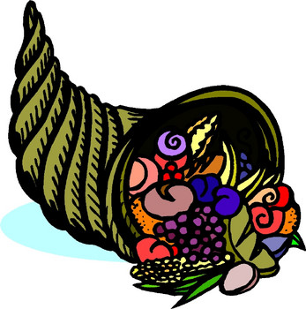 | apple sauce  baked potatoes  beet  broccoli  butter  carrot  cauliflower  corn on the cob  cornucopia  cranberries | dinner roll  grapes  gravy  mashed potatoes  onion  pumpkin pie  squash  sweet potatoes  turkey  yam

